**INFO 6205**

**Program Structures & Algorithms**

**Summer Full 2018**

**Assignment 3 -Test Case**

**Test cases:Intellij**

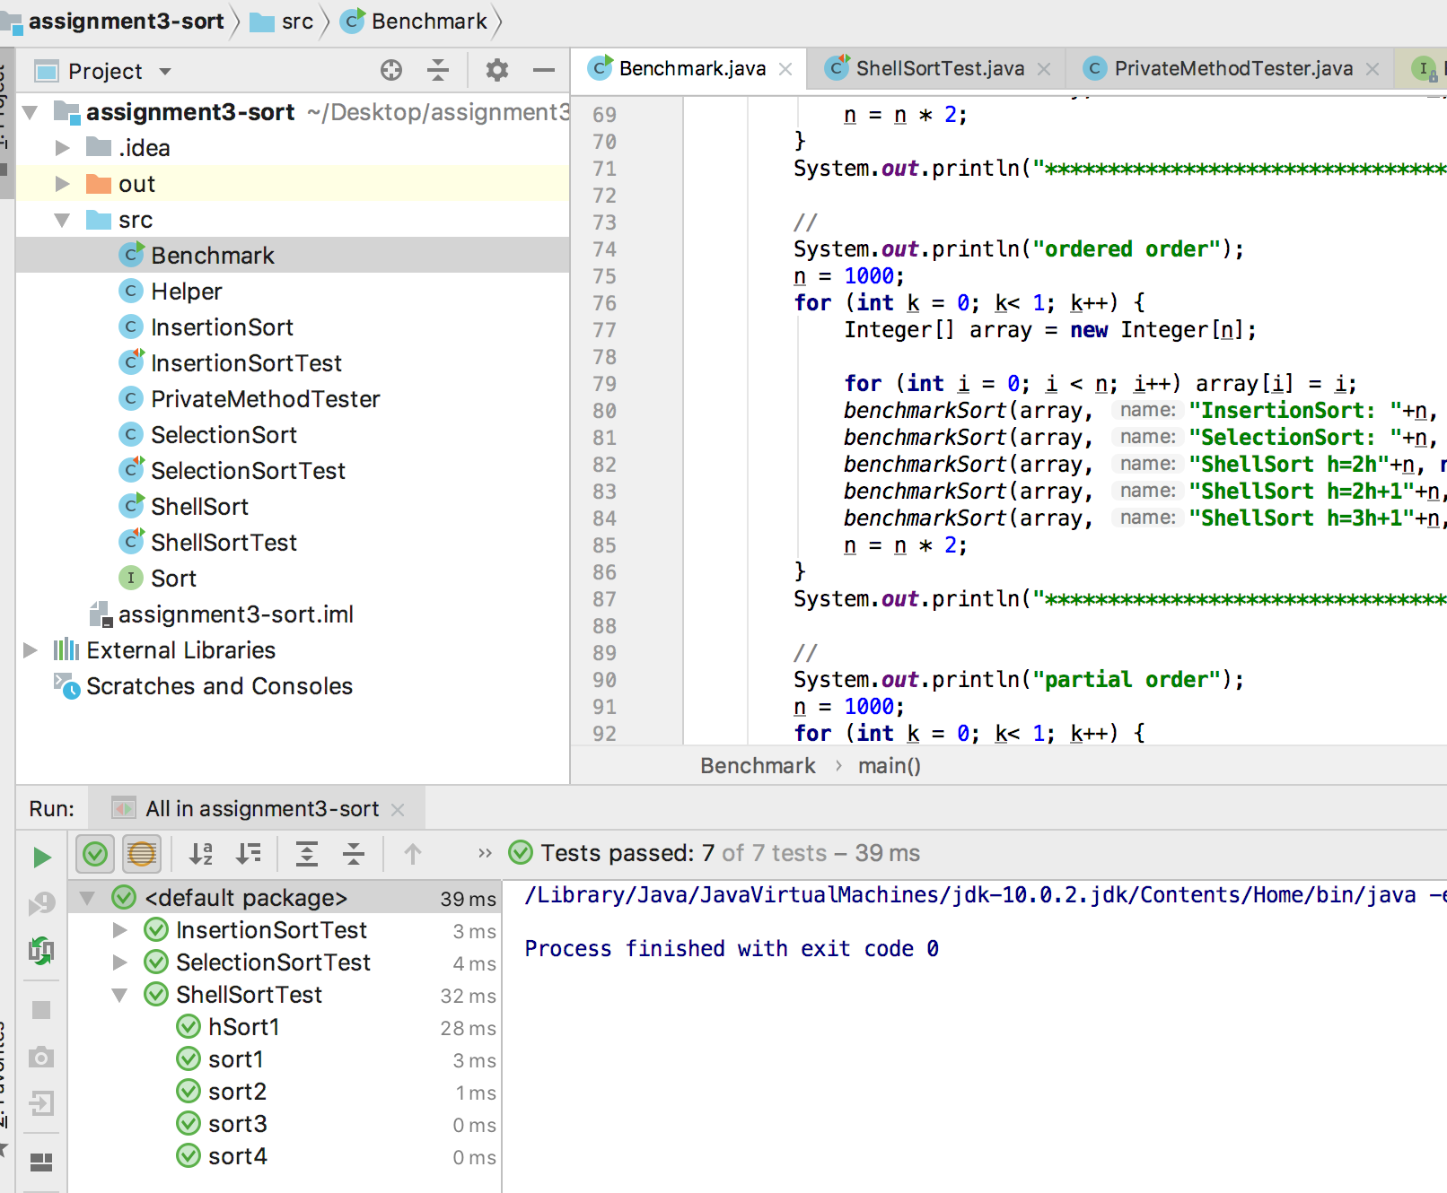

Output result is already showed in the other report.